**PRE-ALPHA V1_CI8359_AERO BTS_FR_QA-FEEDBACK**

1. Please remove the following extra space unless these are SFMC bugs, which cannot be fixed.

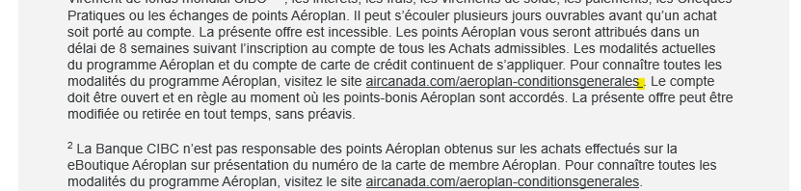

1. VGARO card name is not populating:

1. Please add asterisk for the following legal line to match NN. Copydeck will be updated.

1. Thin line across the header section on real Outlook Office 365 (120 dpi)-Windows 11. This feedback was dismissed for EN. Please confirm if it needs to be dismissed for FR as well.

1. Thin white line on real Outlook Office 365 (120 dpi)-Windows 11:

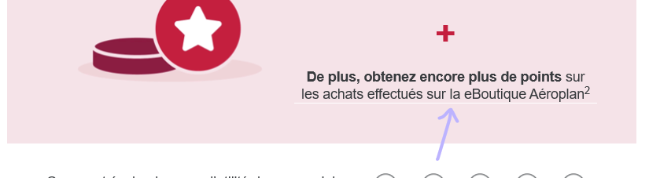

1. The Instagram icon is slightly cut off on the bottom on several Outlook-Windows versions, including real Outlook Office 365 (120 dpi)-Windows 10. This was dismissed for EN. Please confirm if it needs to be dismissed for FR as well.

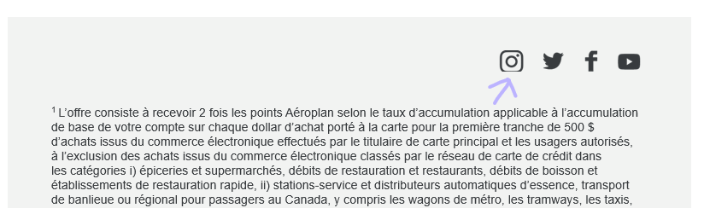

1. Please update so that the headline/subheading are above the header image on mobile view.
2. Mobile view: Although the padding matches Creative, please update it so that’s it’s consistent with our CIBC standard (40 px on top and bottom)

1. Samsung Galaxy S10+ Gmail: widow word “sur”

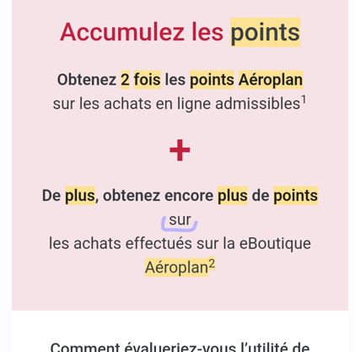

1. Outlook 2016-Windows 10: thin white line

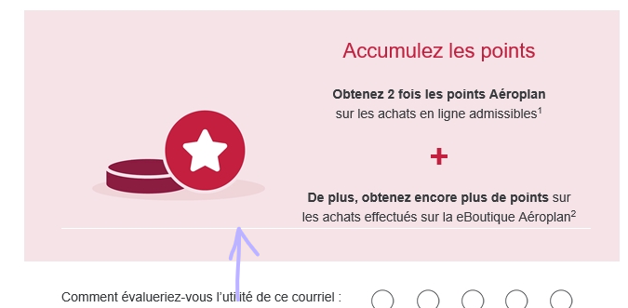

1. Rendering issue on some iOS clients like iPhone 11 Pro & iPhone 12 (EOA).

